Presentation
Code Calculation

Presentation for

Applied Information Technology 2b



The impact of the internet (social networking) on society

Date Submitted: Number of Words:

Signature: I xxxxxxxxxxx advise that this work submitted is my own work and has not been copied or reproduced without reference to the appropriate author.

Table of Contents

1. Convert the following decimal numbers to their binary equivalent.

- 25=
- 10=
- 181=
- 327=

Binary numbers are made up as follows

128 64 32 16 8 4 2 1

So to find and binary number from ASCI or DEC number

We use the binary numbers

The letter B represents 66 we need to find the binary code for 66

128 | 64 | 32 | 16 | 8 | 4 | 2 | 1
0 | 0 | 0 | 0 | 0 | 0 | 0 | 0

We use 1 on or 0 off so if we add 1 to 64 + add a 1 to 2 to make up 66 the other numbers are zero
128 | 64 | 32 | 16 | 8 | 4 | 2 | 1
0 | 1 | 0 | 0 | 0 | 0 | 1 | 0

Binary code for 66 is 01000010

You can make up a table to calculate the codes

Decimal | Octal | Hex | Binary | Value | Description
000 | 000 | 00 | 0000 0000 | NUL | "null" character
001 | 001 | 01 | 0000 0001 | SOH | start of header
002 | 002 | 02 | 0000 0010 | STX | start of text
003 | 003 | 03 | 0000 0011 | ETX | end of text
004 | 004 | 04 | 0000 0100 | EOT | end of transmission
005 | 005 | 05 | 0000 0101 | ENQ | enquiry
006 | 006 | 06 | 0000 0110 | ACK | acknowledgment
007 | 007 | 07 | 0000 0111 | BEL | bell
008 | 010 | 08 | 0000 1000 | BS | backspace
009 | 011 | 09 | 0000 1001 | HT | horizontal tab
010 | 012 | 0A | 0000 1010 | LF | line feed
011 | 013 | 0B | 0000 1011 | VT | vertical tab
012 | 014 | 0C | 0000 1100 | FF | form feed
013 | 015 | 0D | 0000 1101 | CR | carriage return
014 | 016 | 0E | 0000 1110 | SO | shift out
015 | 017 | 0F | 0000 1111 | SI | shift in
016 | 020 | 10 | 0001 0000 | DLE | data link escape
017 | 021 | 11 | 0001 0001 | DC1 | device control 1 (XON)
018 | 022 | 12 | 0001 0010 | DC2 | device control 2
019 | 023 | 13 | 0001 0011 | DC3 | device control 3 (XOFF)
020 | 024 | 14 | 0001 0100 | DC4 | device control 4
021 | 025 | 15 | 0001 0101 | NAK | negative acknowledgement
022 | 026 | 16 | 0001 0110 | SYN | synchronous idle
023 | 027 | 17 | 0001 0111 | ETB | end of transmission block
024 | 030 | 18 | 0001 1000 | CAN | cancel
025 | 031 | 19 | 0001 1001 | EM | end of medium
026 | 032 | 1A | 0001 1010 | SUB | substitute
027 | 033 | 1B | 0001 1011 | ESC | escape
028 | 034 | 1C | 0001 1100 | FS | file separator
029 | 035 | 1D | 0001 1101 | GS | group separator
030 | 036 | 1E | 0001 1110 | RS | request to send/record separator
031 | 037 | 1F | 0001 1111 | US | unit separator
032 | 040 | 20 | 0010 0000 | SP | space
033 | 041 | 21 | 0010 0001 | ! | exclamation mark
034 | 042 | 22 | 0010 0010 | " | double quote
035 | 043 | 23 | 0010 0011 | # | number sign
036 | 044 | 24 | 0010 0100 | $ | dollar sign
037 | 045 | 25 | 0010 0101 | % | percent
038 | 046 | 26 | 0010 0110 | & | ampersand
039 | 047 | 27 | 0010 0111 | ' | single quote
040 | 050 | 28 | 0010 1000 | ( | left/opening parenthesis
041 | 051 | 29 | 0010 1001 | ) | right/closing parenthesis
042 | 052 | 2A | 0010 1010 | * | asterisk
043 | 053 | 2B | 0010 1011 | + | plus
044 | 054 | 2C | 0010 1100 | , | comma
045 | 055 | 2D | 0010 1101 | - | minus or dash
046 | 056 | 2E | 0010 1110 | . | dot
047 | 057 | 2F | 0010 1111 | / | forward slash
048 | 060 | 30 | 0011 0000 | 0
049 | 061 | 31 | 0011 0001 | 1
050 | 062 | 32 | 0011 0010 | 2
051 | 063 | 33 | 0011 0011 | 3
052 | 064 | 34 | 0011 0100 | 4
053 | 065 | 35 | 0011 0101 | 5
054 | 066 | 36 | 0011 0110 | 6
055 | 067 | 37 | 0011 0111 | 7
056 | 070 | 38 | 0011 1000 | 8
057 | 071 | 39 | 0011 1001 | 9
058 | 072 | 3A | 0011 1010 | : | colon
059 | 073 | 3B | 0011 1011 | ; | semi-colon
060 | 074 | 3C | 0011 1100 | < | less than
061 | 075 | 3D | 0011 1101 | = | equal sign
062 | 076 | 3E | 0011 1110 | > | greater than
063 | 077 | 3F | 0011 1111 | ? | question mark
064 | 100 | 40 | 0100 0000 | @ | "at" symbol
065 | 101 | 41 | 0100 0001 | A
066 | 102 | 42 | 0100 0010 | B
067 | 103 | 43 | 0100 0011 | C
068 | 104 | 44 | 0100 0100 | D
069 | 105 | 45 | 0100 0101 | E
070 | 106 | 46 | 0100 0110 | F
071 | 107 | 47 | 0100 0111 | G
072 | 110 | 48 | 0100 1000 | H
073 | 111 | 49 | 0100 1001 | I
074 | 112 | 4A | 0100 1010 | J
075 | 113 | 4B | 0100 1011 | K
076 | 114 | 4C | 0100 1100 | L
077 | 115 | 4D | 0100 1101 | M
078 | 116 | 4E | 0100 1110 | N
079 | 117 | 4F | 0100 1111 | O
080 | 120 | 50 | 0101 0000 | P
081 | 121 | 51 | 0101 0001 | Q
082 | 122 | 52 | 0101 0010 | R
083 | 123 | 53 | 0101 0011 | S
084 | 124 | 54 | 0101 0100 | T
085 | 125 | 55 | 0101 0101 | U
086 | 126 | 56 | 0101 0110 | V
087 | 127 | 57 | 0101 0111 | W
088 | 130 | 58 | 0101 1000 | X
089 | 131 | 59 | 0101 1001 | Y
090 | 132 | 5A | 0101 1010 | Z
091 | 133 | 5B | 0101 1011 | [ | left/opening bracket
092 | 134 | 5C | 0101 1100 | \ | back slash
093 | 135 | 5D | 0101 1101 | ] | right/closing bracket
094 | 136 | 5E | 0101 1110 | ^ | caret/circumflex
095 | 137 | 5F | 0101 1111 | _ | underscore
096 | 140 | 60 | 0110 0000 | `
097 | 141 | 61 | 0110 0001 | a
098 | 142 | 62 | 0110 0010 | b
099 | 143 | 63 | 0110 0011 | c
100 | 144 | 64 | 0110 0100 | d
101 | 145 | 65 | 0110 0101 | e
102 | 146 | 66 | 0110 0110 | f
103 | 147 | 67 | 0110 0111 | g
104 | 150 | 68 | 0110 1000 | h
105 | 151 | 69 | 0110 1001 | i
106 | 152 | 6A | 0110 1010 | j
107 | 153 | 6B | 0110 1011 | k
108 | 154 | 6C | 0110 1100 | l
109 | 155 | 6D | 0110 1101 | m
110 | 156 | 6E | 0110 1110 | n
111 | 157 | 6F | 0110 1111 | o
112 | 160 | 70 | 0111 0000 | p
113 | 161 | 71 | 0111 0001 | q
114 | 162 | 72 | 0111 0010 | r
115 | 163 | 73 | 0111 0011 | s
116 | 164 | 74 | 0111 0100 | t
117 | 165 | 75 | 0111 0101 | u
118 | 166 | 76 | 0111 0110 | v
119 | 167 | 77 | 0111 0111 | w
120 | 170 | 78 | 0111 1000 | x
121 | 171 | 79 | 0111 1001 | y
122 | 172 | 7A | 0111 1010 | z
123 | 173 | 7B | 0111 1011 | { | left/opening brace
124 | 174 | 7C | 0111 1100 | | | vertical bar
125 | 175 | 7D | 0111 1101 | } | right/closing brace
126 | 176 | 7E | 0111 1110 | ~ | tilde
127 | 177 | 7F | 0111 1111 | DEL | delete

15. Network topology Show three types of network topology

Answer: Bus Topology
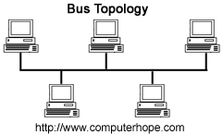

Answer: Star Topology
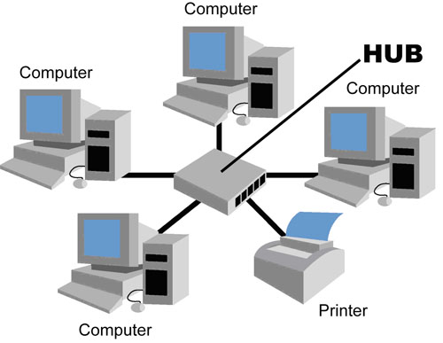

Answer: Ring Topology
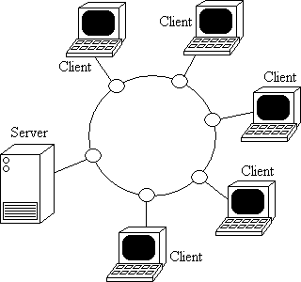

END OF WEB QUEST

